How to restore the SD card
Pls take the following steps:

Run the update tool V2.3
Click Restore system
Select CR Plus or icarsoft 2nd generation accordingly.
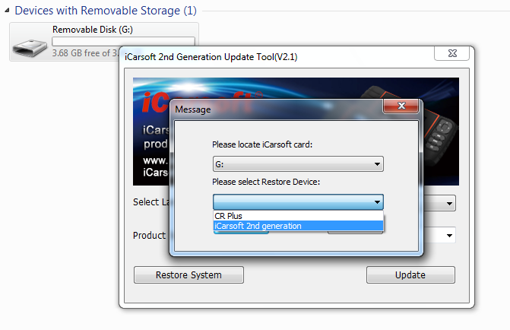

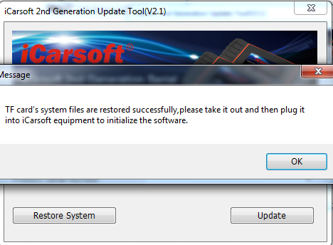

Follow these instructions:
Take out SD card and plug it into iCarsoft device
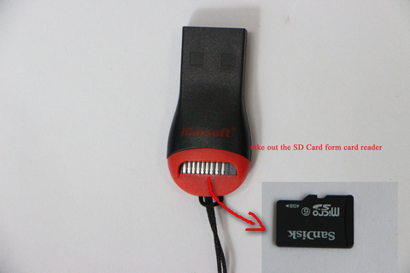
plug SD card into iCarsoft device
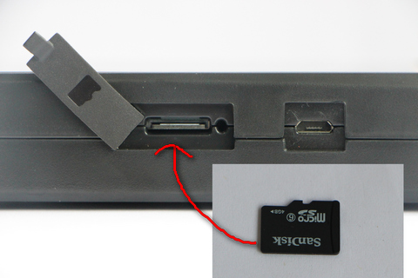

connect the device to computer via USB cable.

Click OK,after finish,take out SD card and use card reader to connect to PC.
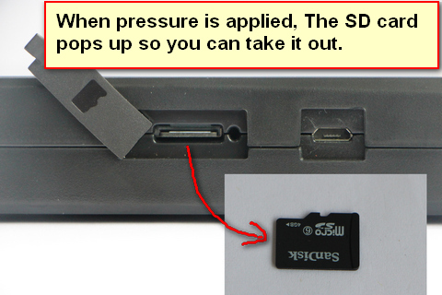
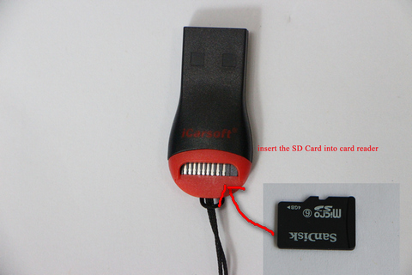

use card reader to connect to PC.

Run the update tool again,you will enter:
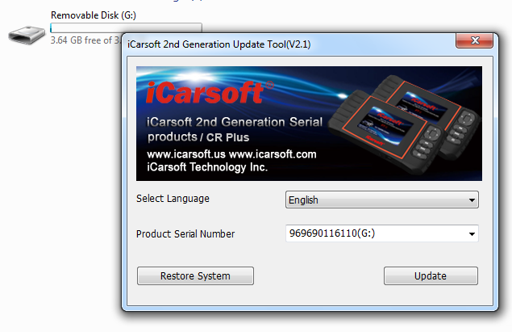
Click update,you can update the device
