How to Upgrade
For V10/V20
- Get setup package
Download the iCarsoft_MSDIAG_PCClientKits.exe package from http://www.icarsoftech.de or from your dealer.
- Installation
Run the installation package, just click [Next] button all the way, and finish the installation.
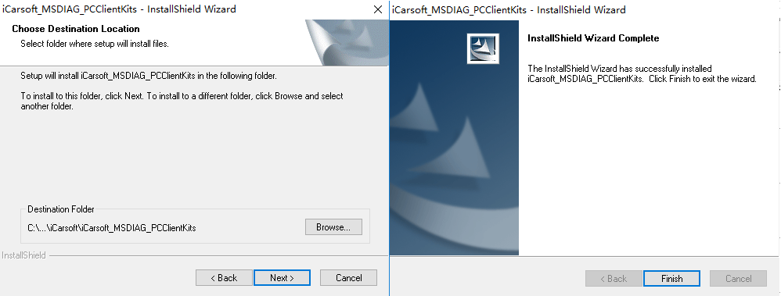
- Connect PC
Connect the scanner to PC via USB data cable or via TF card reader, PC will recognize one more removable U-disc.
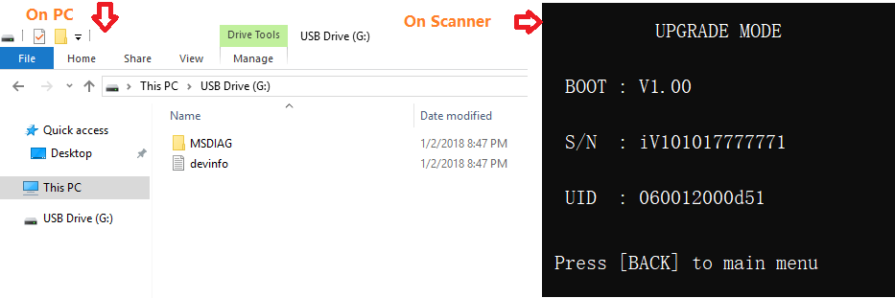

- Start application
Run the application iCarsoft_MSDIAG_PCClientKits on your PC, the application will recognize the scanner by SN.
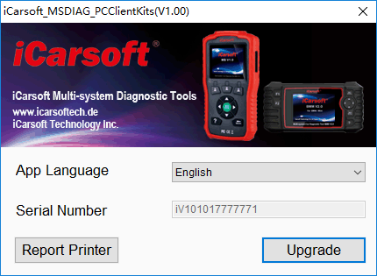
Exception:
  - Key in SN and UID
If you have a new TF memory card for upgrade, the application cannot recognize SN and UID, the SN and UID will be asked. Submit SN and UID which show on the scanner’s screen to continue.
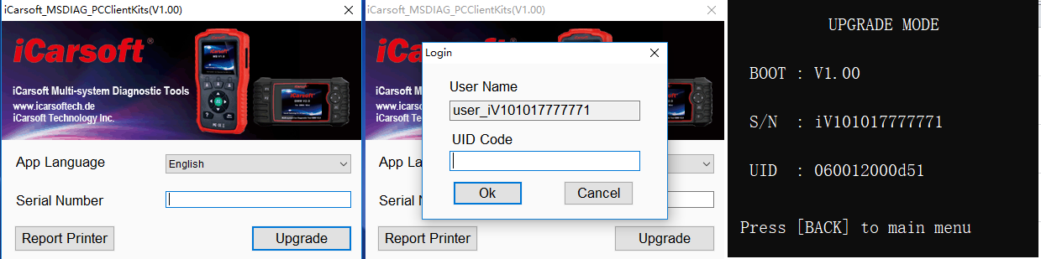
- Login / Registration (PC should connects to internet)
Click [Upgrade] button to login and start visiting upgrade center. If the scanner is first time to visit the upgrade center, the registration step will be asked. Submit your email and UID which show on the scanner’s screen to complete registration.
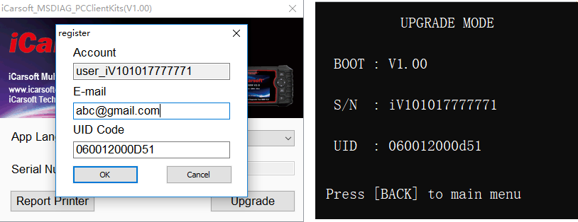
Exception:
  - Application self-upgrade
If the application iCarsoft_MSDIAG_PCClientKits has a new version on the upgrade center, the application upgrade will be asked, chose [YES] to download the newer version, then to install automatically.
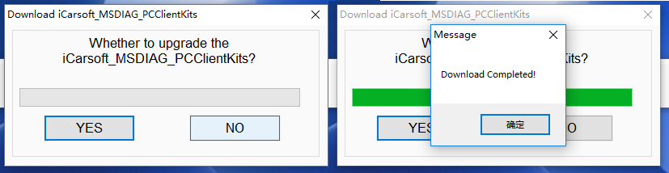

- Upgrade
Press Download button to start software upgrade.
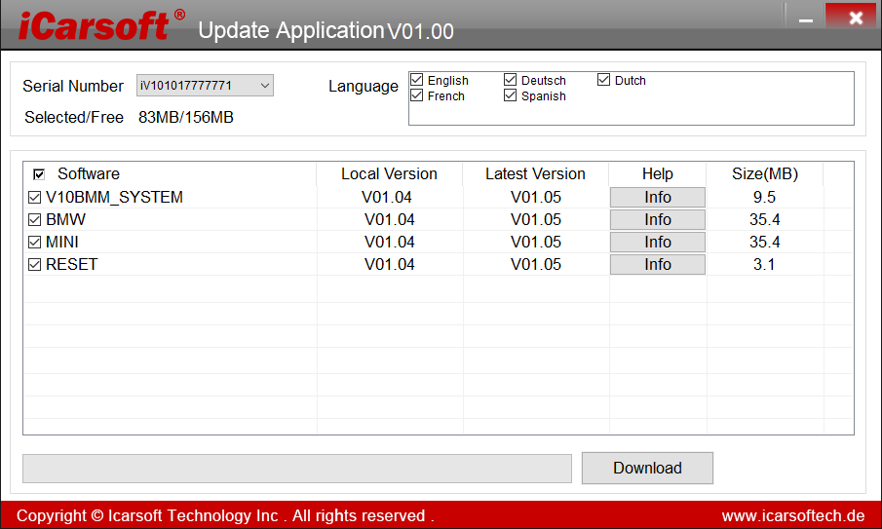
Select About from the main menu, the versions will be listed as flows:
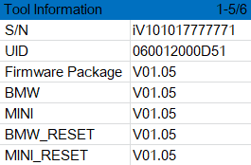
Exception:
  - More storage space
If the free storage size is NOT enough for the upgrade, the application will ask whether to remove the LOG/RECORD for more space? Then the application will ask whether to remove the old version for more space? Click [YES] button to remove related files for more space.

How to Print Report
For V10/V20
- Save data
User can press [RECORD] button to save the diagnosis data such as Module Information, Live Data, Fault Code, Freeze Frame and Vehicle Information ect., the data will be saved as *.rex file on the TF memory card, these files can be used to create diagnosis report by the application iCarsoft_MSDIAG_PCClientKits.
- Supposed the application iCarsoft_MSDIAG_PCClientKits has already being installed correctly. If NOT, please refer to above “How to Upgrade”.
- Launch Report-Printer
Press the button [Report Printer] to launch Report-Printer center.
- Select files.
BMW_EN_TEST_0001 shows all recorded data with BMW Diagnosis Software.
OBD_EN_ TEST_0001 shows all recorded data with OBD Diagnosis Software.
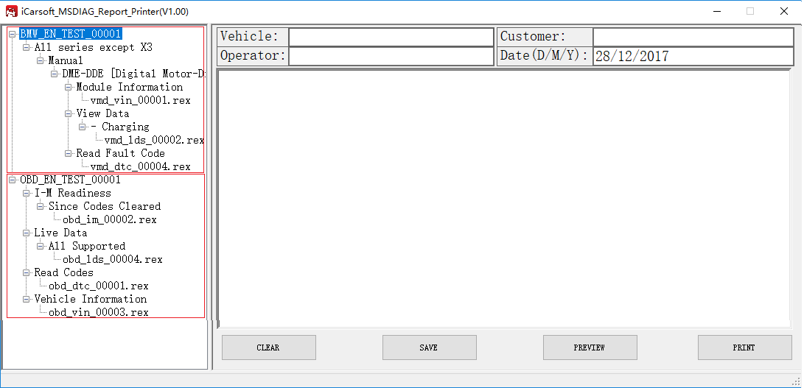
Click the *.rex to add the data to edit box.
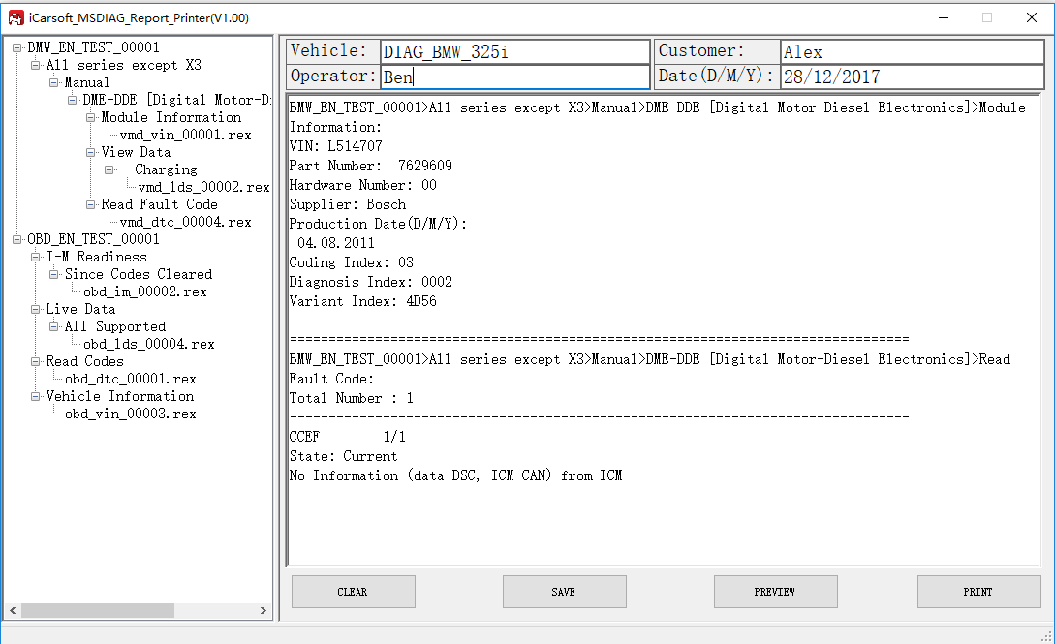
[CLEAR] button to clear all data in the edit area,
[SAVE] button to save all data in the edit area as a text file,
[PREVIEW] button for printer-preview,
[PRINT] button to print all data in the edit area.
- Example
Copy files Recorded_File_OnTFcard_for_Example\MSDIAG to TF card to verify the report printer.
See the attached OBDII_FORD_F150.pdf and DIAG_BMW_325i.pdf as export files

