1. Setup Update tools
Put the CD in to PC and open. You can see the setup file in the CD.

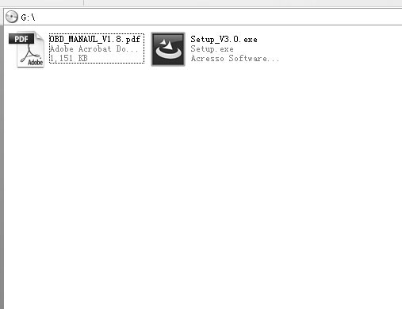

Double click the [Setup file] to setup the tool.
Operate follow the instructions, and finish to setup.
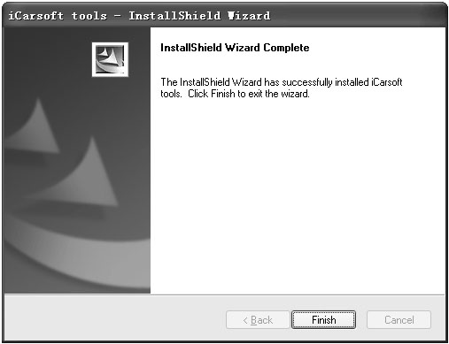

After finish setup, there is an icon of scanner in desktop.

2. Run the update tool and Operate in accordance with.

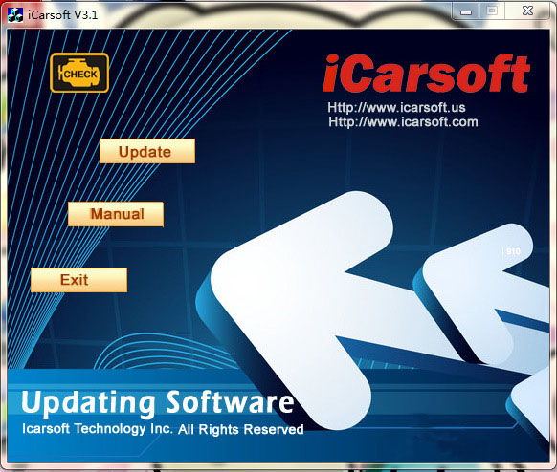

a) Use the USB cable to connect i810 scanner with PC.

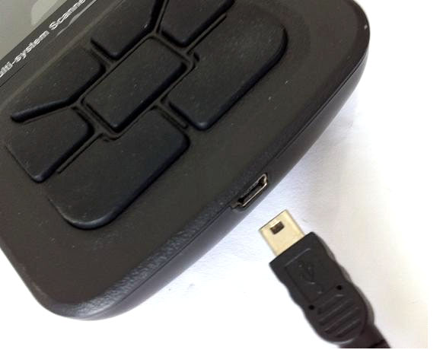

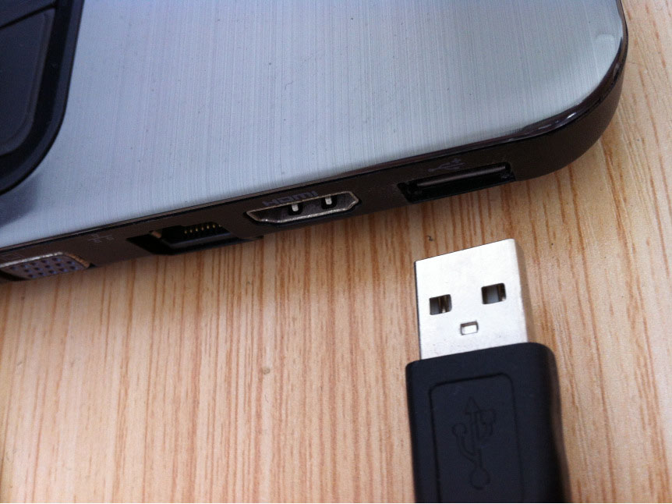

When the scanner is connected with PC , the software will show [USB CONNECTED], As below:

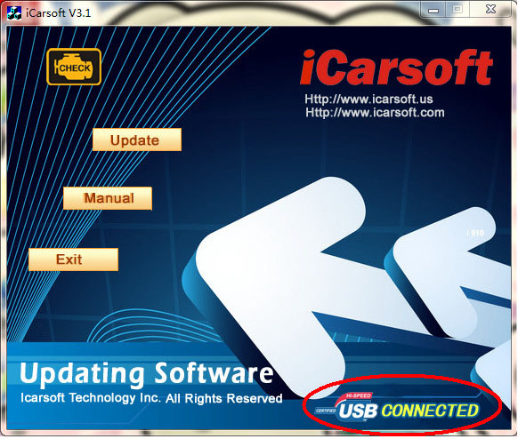

1) Click [Update] button.
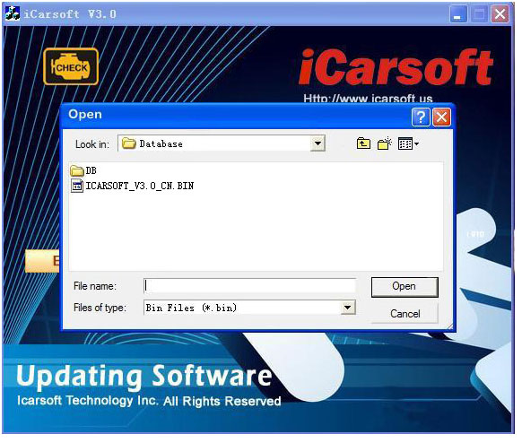

2) Select update file and click [open] button.
3) Into the upgrade interface, wait for the end of upgrade

WARNNING:
Do not power off during upgrade!
Do not Plug or Unplug USB tools during upgrade!

Start Update
Waiting for a few minutes. The software will update the scanner tool.

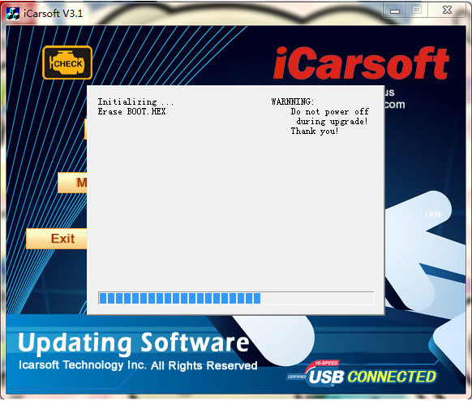

Finish Update
When the update is finished, the screen on PC will show as below.

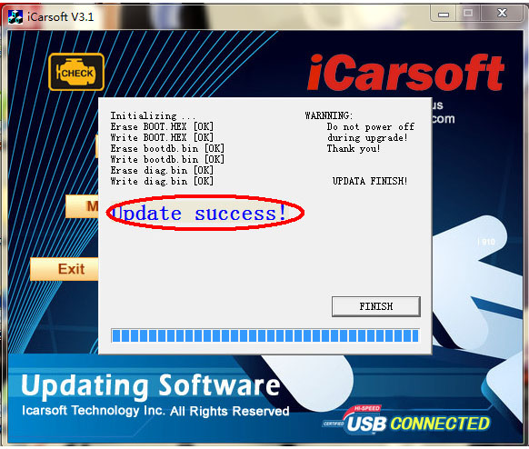

If update success, the software wil display [Update success!];
if update not success, it will display [Update fail! Try again].

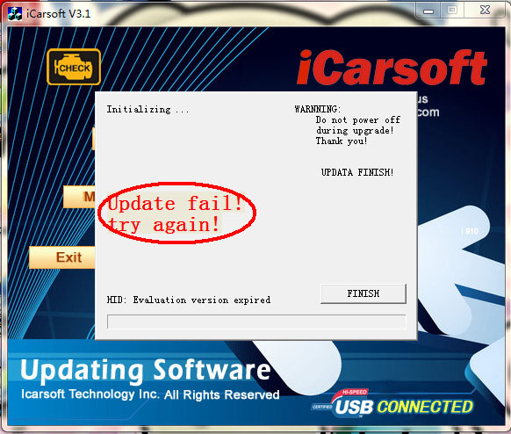

Press [finish], the scanner is already updated, and you can unplug the scanner from PC.

